Capstone Project 3

**Healthcare Analytics - Capstone Project**

The different types of view show in the dashboard are :-

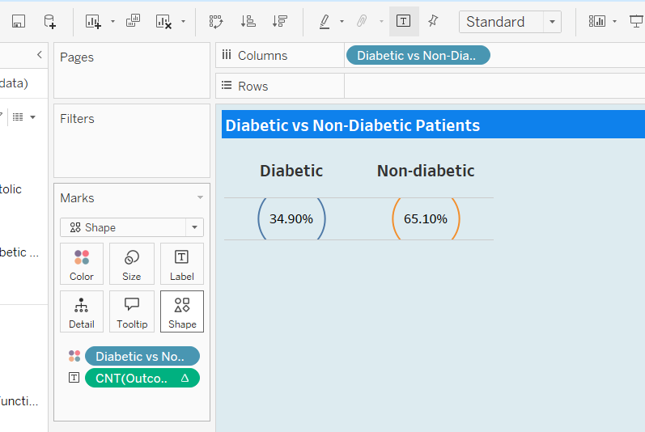

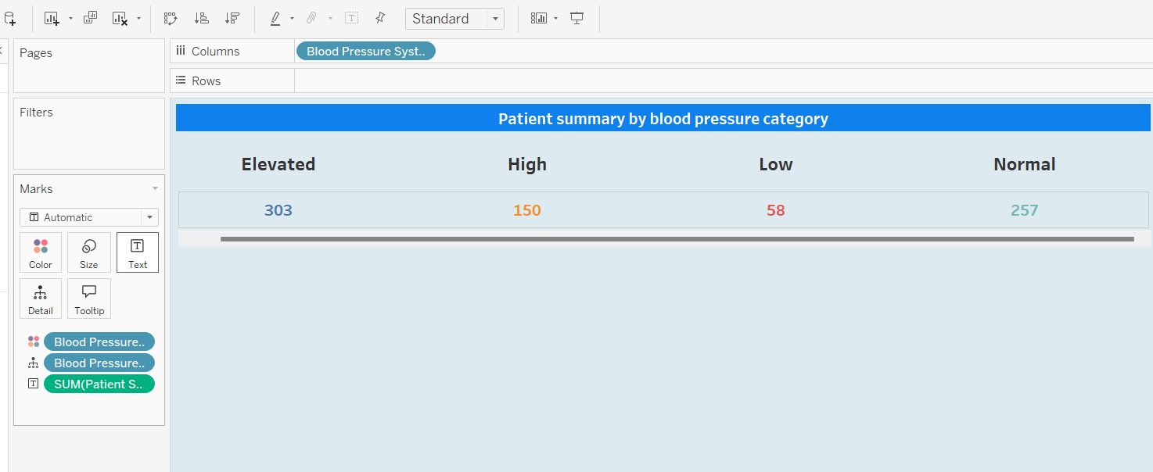

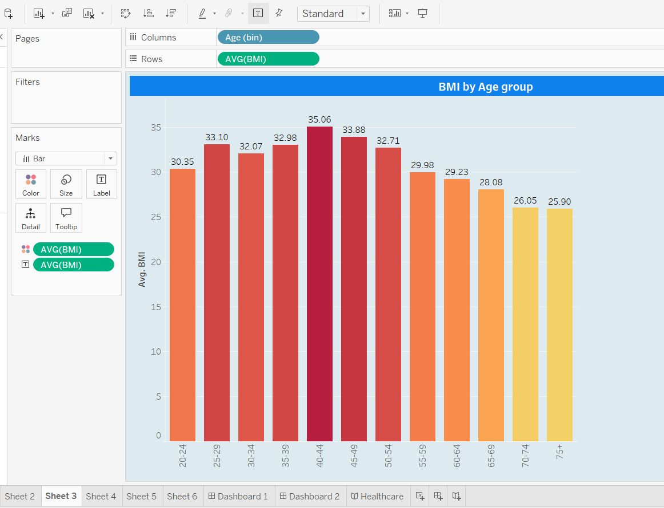

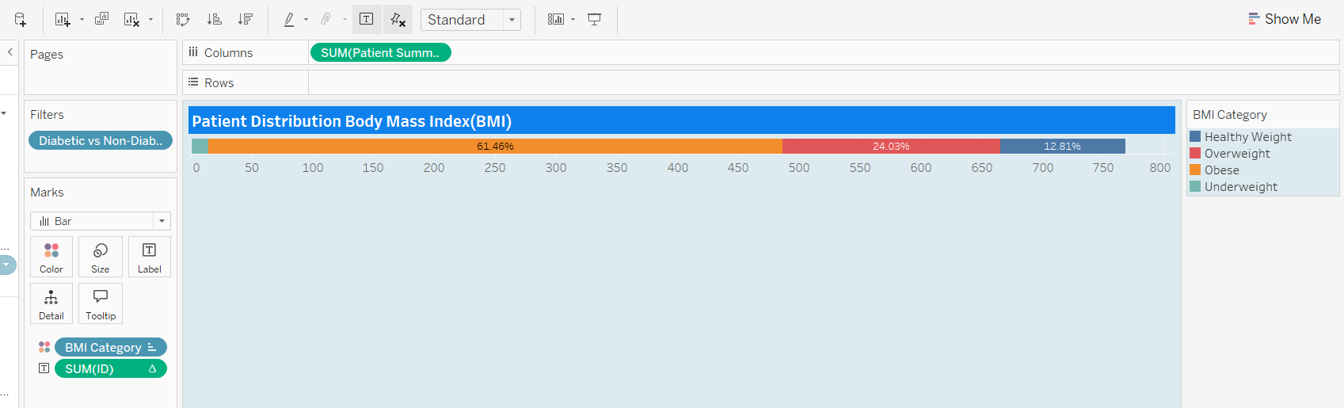

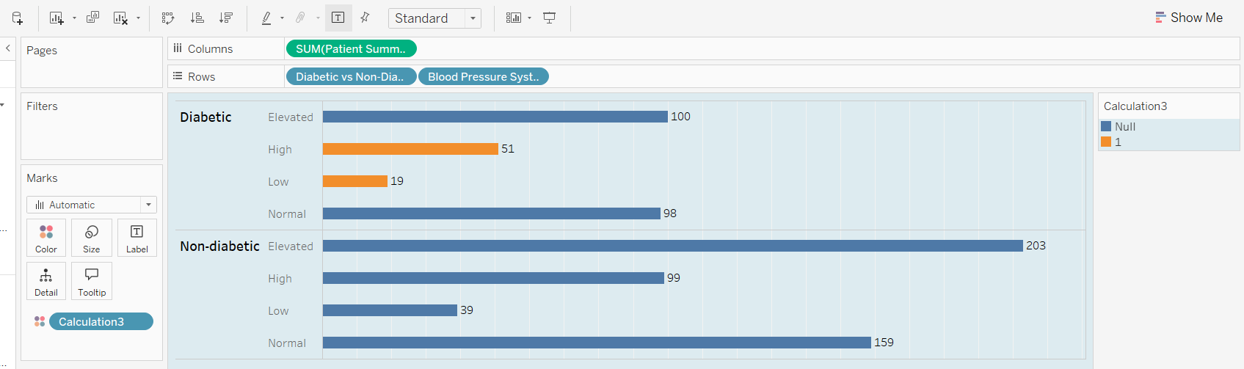

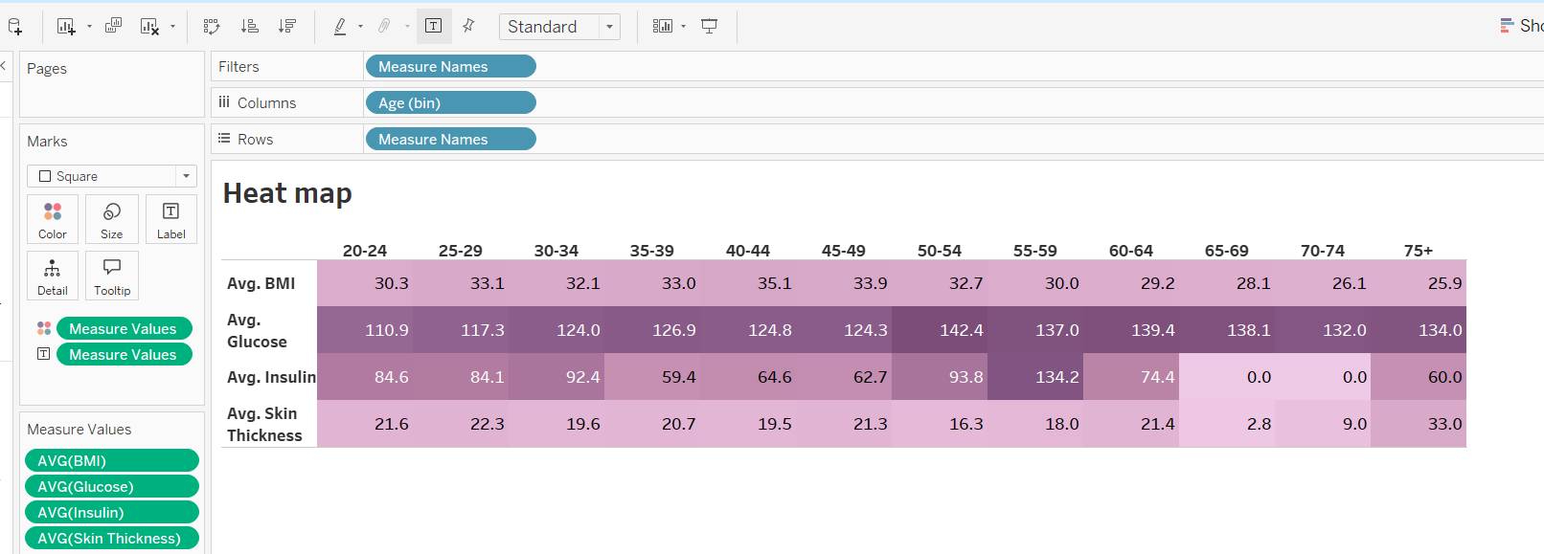

Now by using this different view I have created dashboards and a story layout.

The first dashboard view:

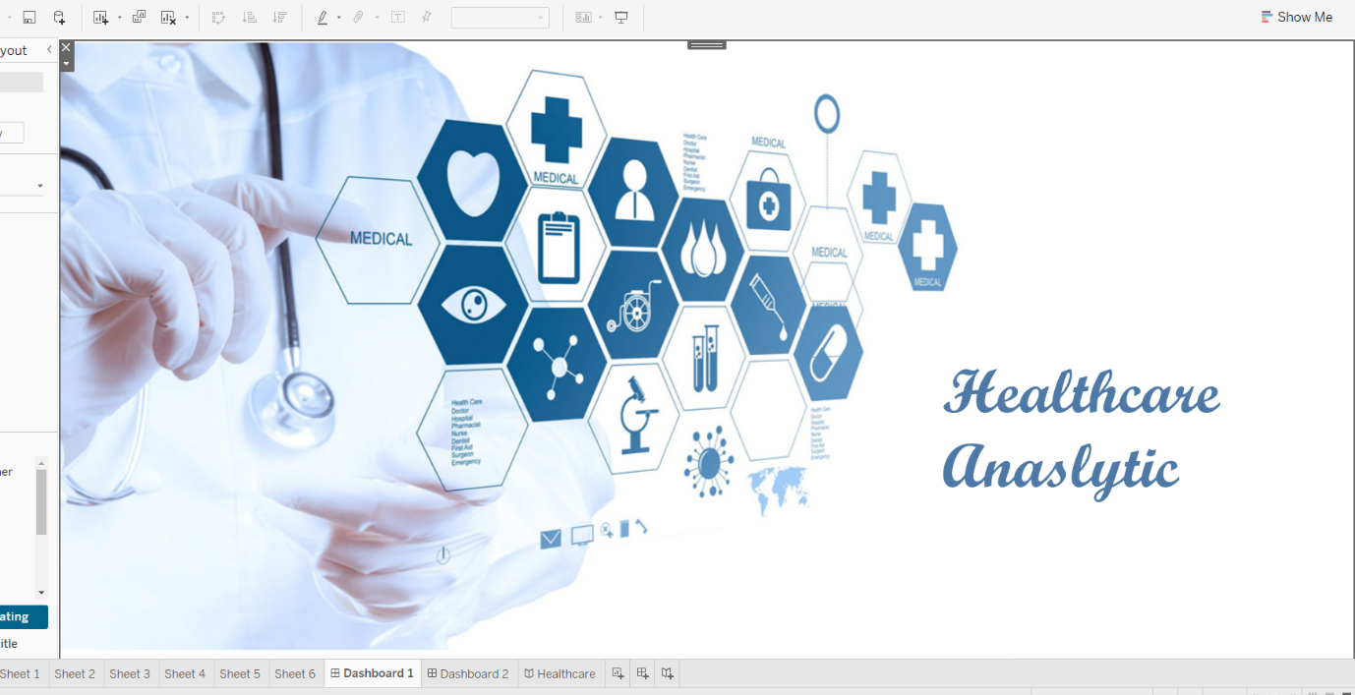

The second dashboard view:

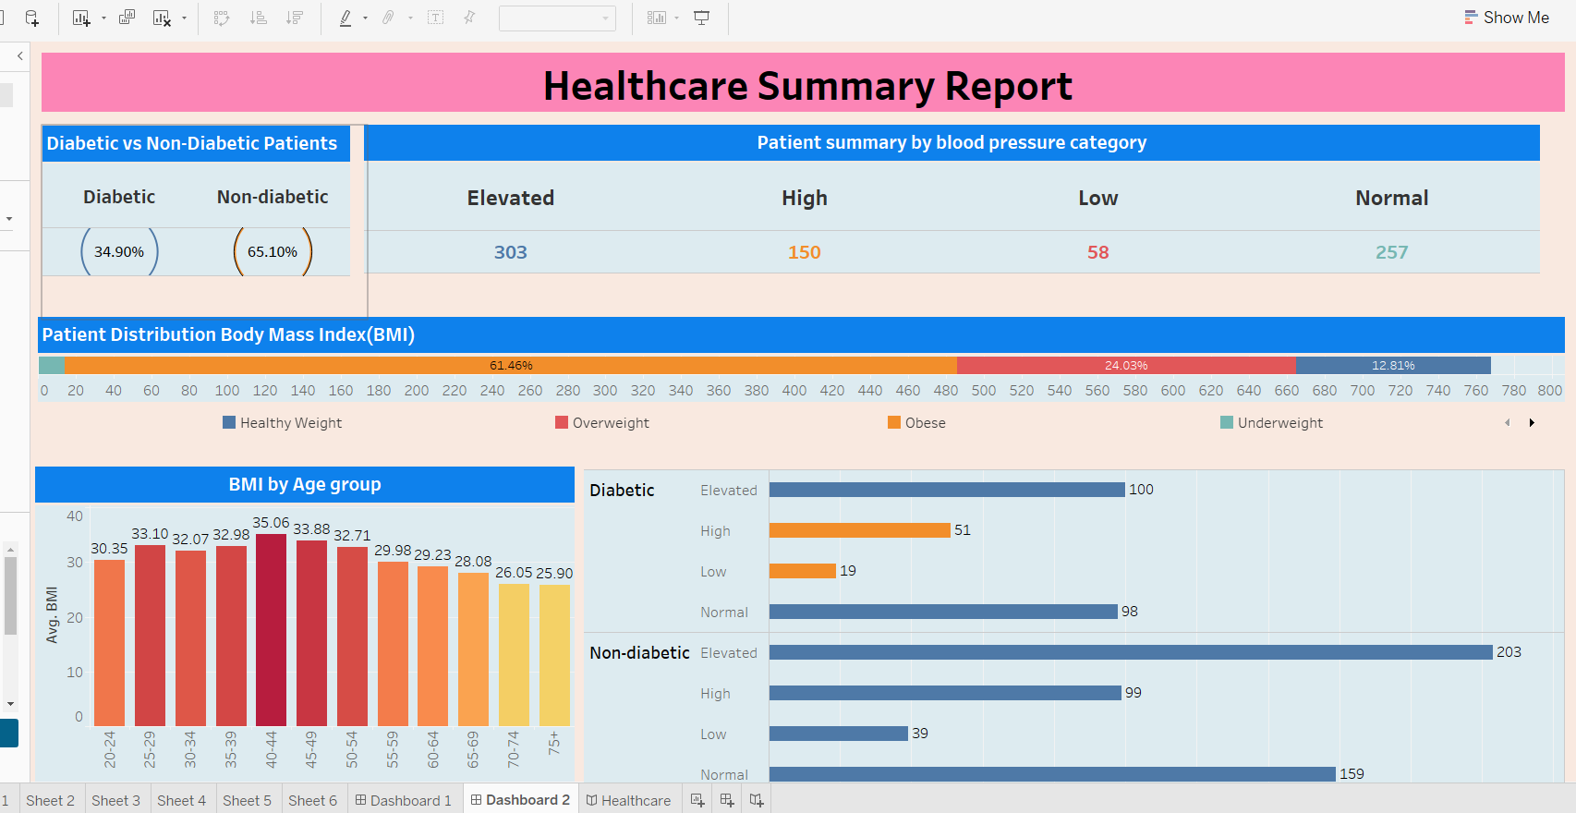

The Story layout:



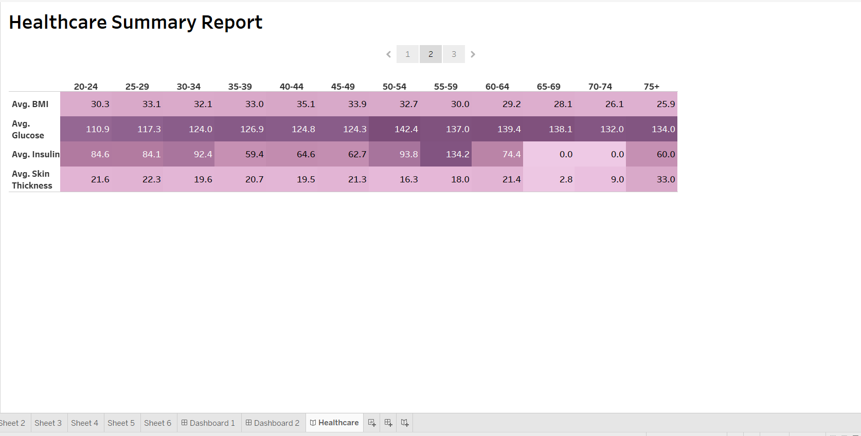

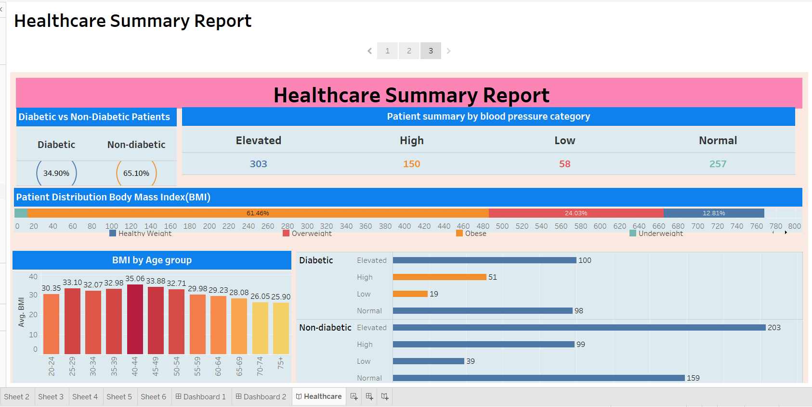

Here I am attaching my tableau public link, through which any one can paste this link on their browser and see my work.

<https://public.tableau.com/views/Capstone3_17236542865460/Healthcare?:language=en-US&publish=yes&:sid=&:redirect=auth&:display_count=n&:origin=viz_share_link>